

**Project Report**

**MVC FrameWork Watch Store**

**Object Oriented Analysis & Design**

**Group Members:**

1.

Muhammad Nomir 11330

2.

Asad Tariq Sheikh 11355

**Submitted To:**

Sir Sohail Imran

**Date: May 19, 2022**

**ACKNOWLEDGEMENT:**

*“This Report Have Been Prepared Through The Help Of Online Consultation Of Different Webpages For Datasheets & Also In This Report We Explain Our Project Thoroughly. This Project Report Have Been Created Within The Given Time Spectrum. All Of The Given Requirement Are In This Report With Correct Format.”*

**ABSTRACT:**

In this whole report you will see all our research and hard-work put into this report. We created a project with **MVC Framework** and the website we made with the framework was named **WatchStore** we will explains’ the functionalities of the website and also show the different UML diagrams that were developed with this MVC framework project.

**SCOPE:**

The scope of this project is not just to develop a working MVC framework website but also understand a website is developed in a proper manner and how in the future and becoming a project analyst we will have to develop UML diagrams so that a team of developers can easily understand every piece of information given in the diagrams.

**OPERATING ENVIRONMENT:**

1. Visual Studio 2019 (with proper & additional installations)

2. MVC Framework 5

3. SQL Server Management Studio 2019

4. Azure Hosting

5. Support of HTML, CSS, Bootstrap and jQuery

**LINKS:**

**GitHub:**

<https://github.com/Nomir-01/OOAD-Project>

**Azure (Web Hosting):**

<https://watchstoreapp.azurewebsites.net>

Email -------> asad@gmail.com

Password -------> asad123

**Admin Panel:**

<https://watchstoreapp.azurewebsites.net/Auth/SignIn>

Username -------> asad

Password -------> asad123

**WATCH STORE (WEBSITE):**

Our website is simple but highly functional, the basic functions are that a customer can browse the website add the products to cart login to account, register to account, checkout and while checking out increase or decrease the quantity of a product or also remove an item, customer can also cancel their order at any given point in time.

The admin can add a new brand of watches in the website and also edit, delete or add any products in the website of the brands, the admin can also see order details, edit their status or even delete the orders.

The system works on managing the website stocks and orders such that if a customer decreases the quantity or increases the system is to manage the stock of the products accordingly, or if the admin edits a product or adds a new brand category, the system is to manage that as well.

**IMPORTANCE OF ADMIN PANEL:**

The admin panel is an important functionality that just doesn’t helps in managing the orders but also the website. The admin panels helps’ in increasing our brand categories without accessing the code, if we want to increase two three or even four categories the admin panel allows us to do that and also add products to that brand new category without having to access the code, we can add as many products as we want and edit is as many times as we want.

The admin panel also helps us in managing the orders either seeing the details or editing the order status accordingly or even deleting the order if it is not needed anymore.

**DATABASE:**

We chose SQL Server as our database platform, we choose this because we had the most hands-on on this software, also connecting a SQL server database to a MVC framework is easier and it allows us to create the Model Class without any complexities and ease and also our hosting platform azure supports SQL server database so it was an obvious choice to use this software.

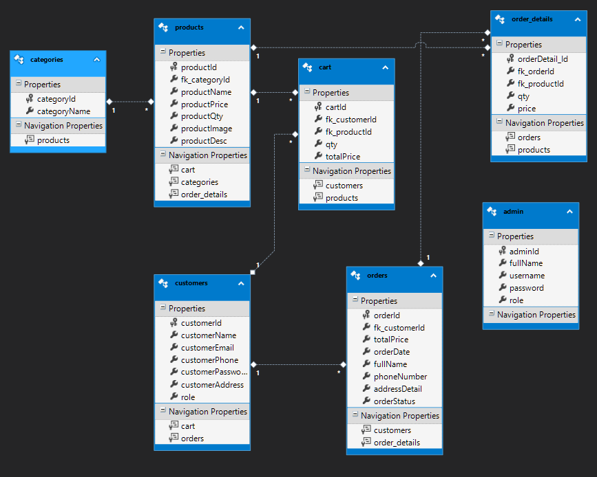

**WEB HOSTING:**

We chose azure as our hosting platform as it provides a free 12-month service, which for the time spectrum of our project was more feasible and also affordable. Azure also helps us in connecting our database directly to the MVC framework so this is the second reason we choose azure as our hosting platform.

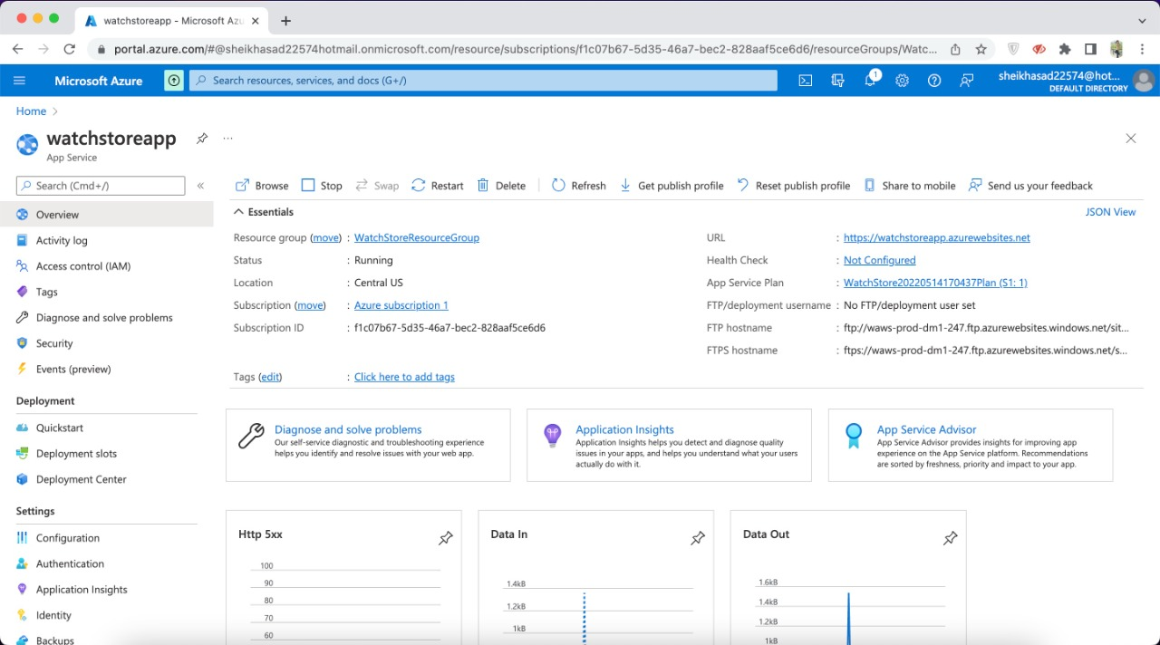

**WEBSITE GUI:**

We chose a basic and simple design for our website so that a customer can easily browse, search or buy products. For this we used basic HTML and CSS, we also used templates of JQuery and Bootstrap in our website. Our website is also responsive and the minimal design allows it to be used conveniently on different size of devices.

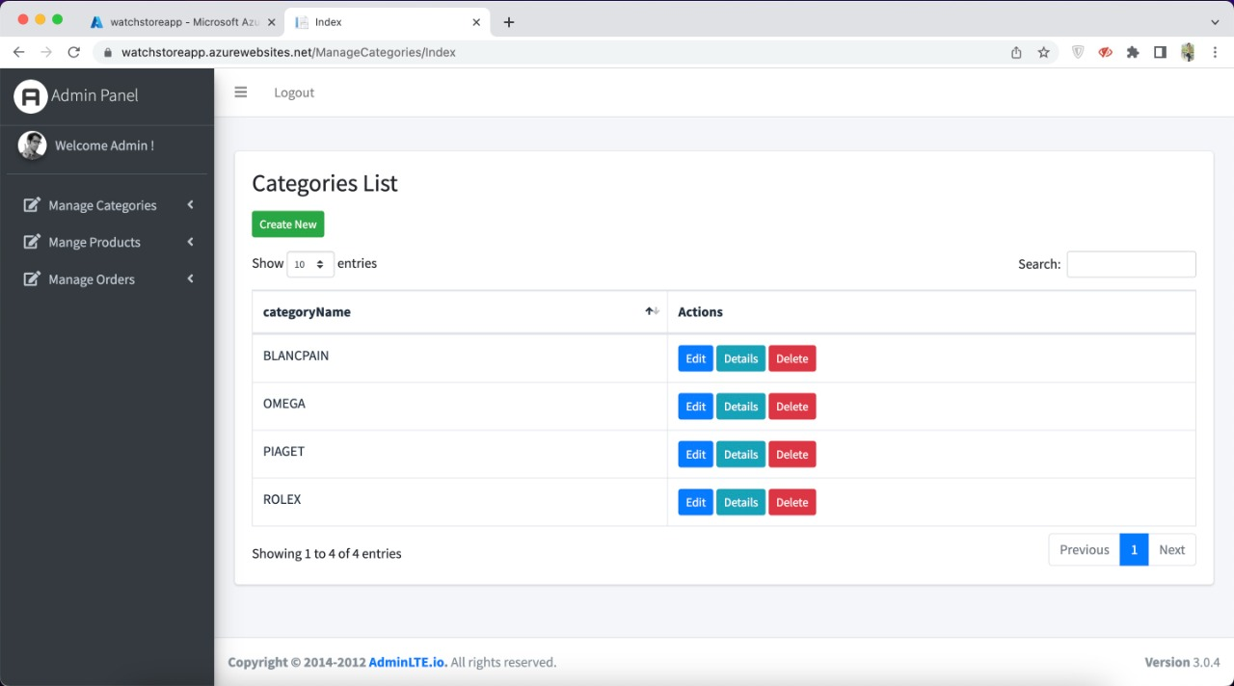

**USE CASE DIAGRAM:**

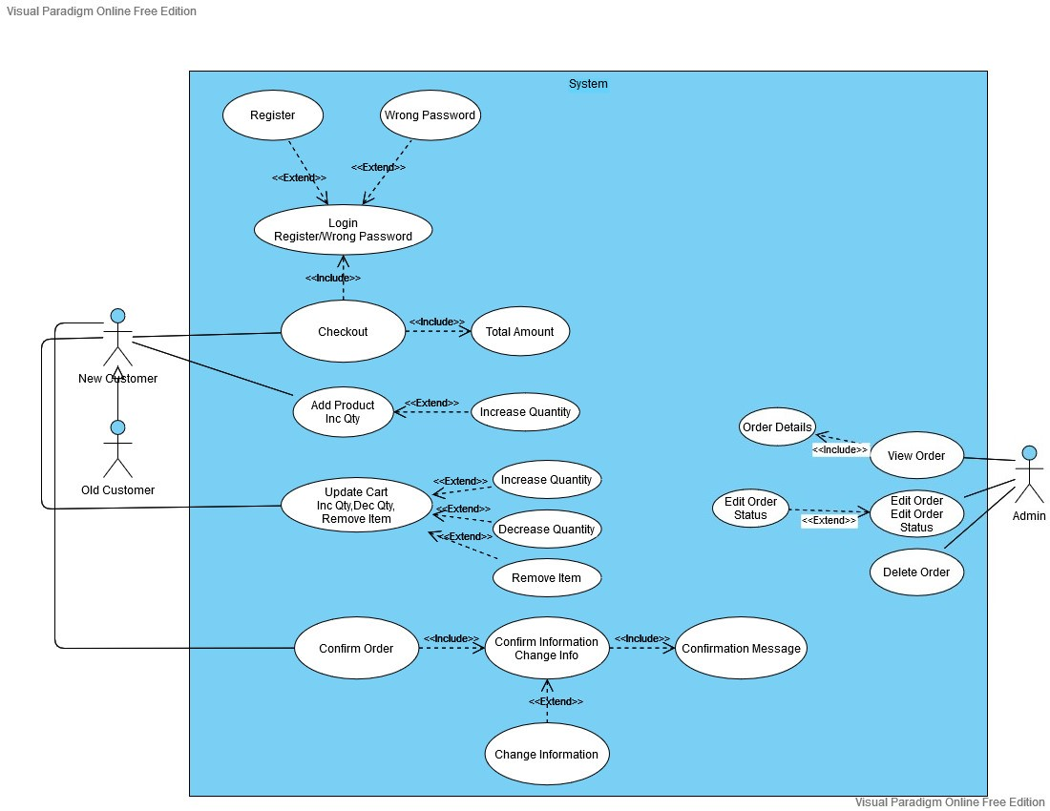

The use case diagram explains the general use case of our transaction form. It explains how a user can checkout without or with login and which conditions will be triggered when checking out without login. It also shows that user can update their cart to their liking and also they have to confirm their information when checking out. It also shows the admin side uses on how admin can view, edit or delete the order.

**ACTIVITY DIAGRAM:**

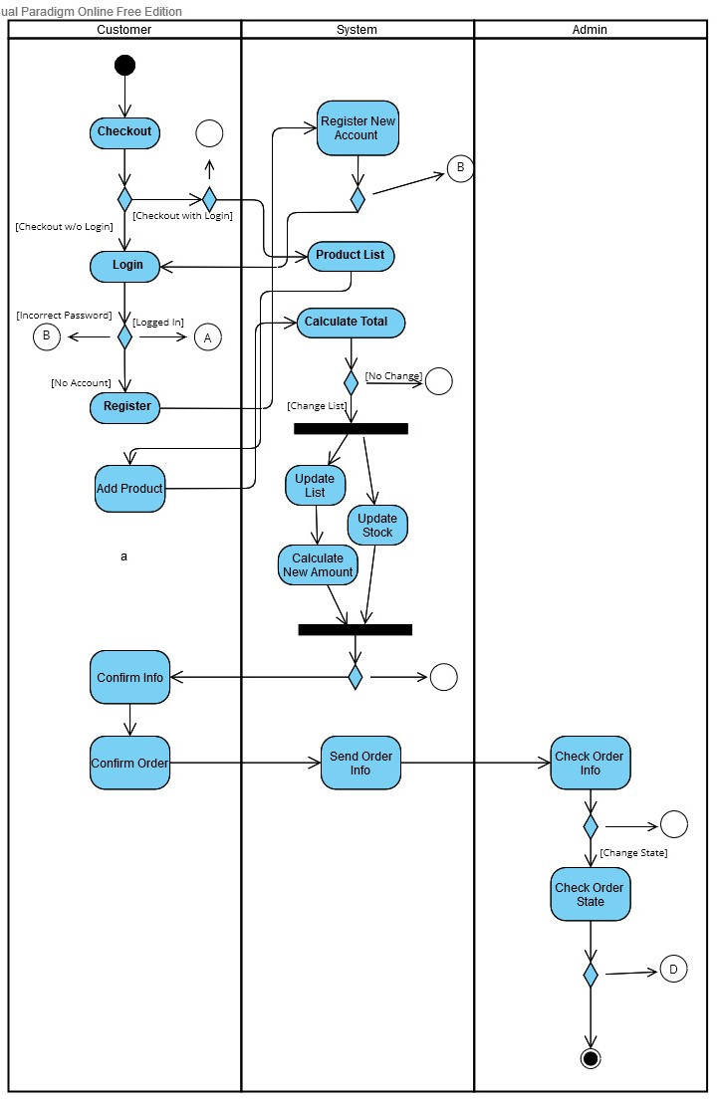

The activity diagram explains the activities of our transaction form. It shows the different conditions and activities happening in the project. It shows the parallel happening activities.

**CLASS DIAGRAM:**

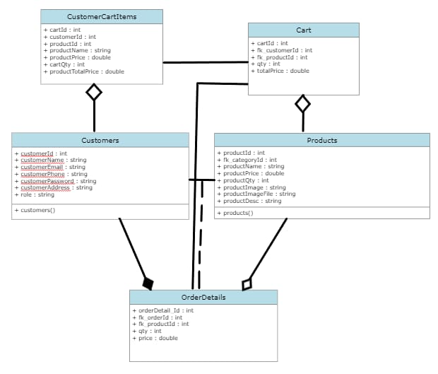

The class diagram explains the classes working in our transaction form, this diagram also tells us association, aggregation & composition between classes.

**SEQUENCE DIAGRAM:**

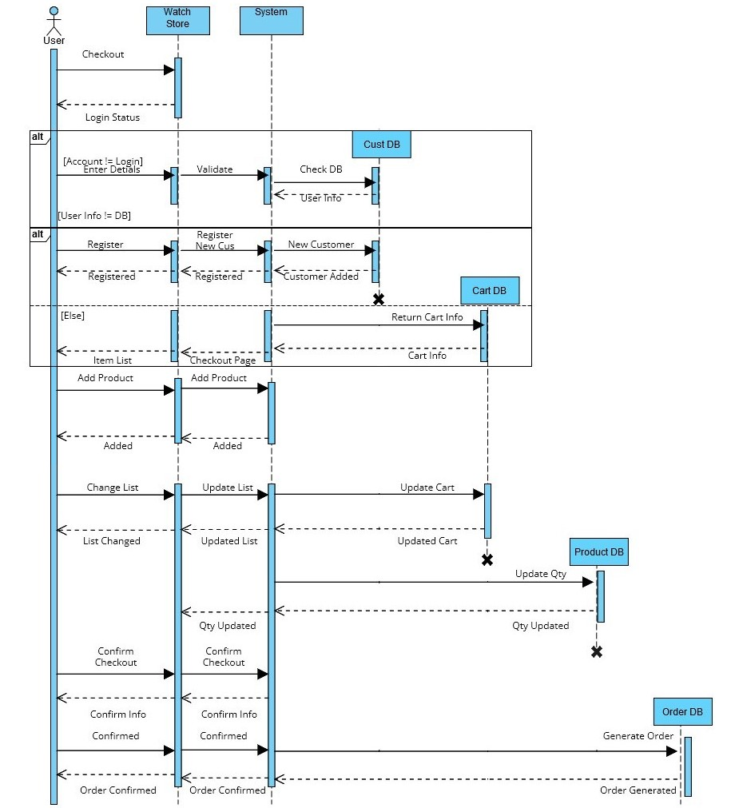

The sequence diagram explains the general sequence of our transaction form. It explains how a user can checkout and which conditions will be triggered on specific actions and how the database will react accordingly. It also shows that user can update cart. The user also has to confirm their information and this confirmed information will generate order from database.

**COLLABORATION DIAGRAM:**

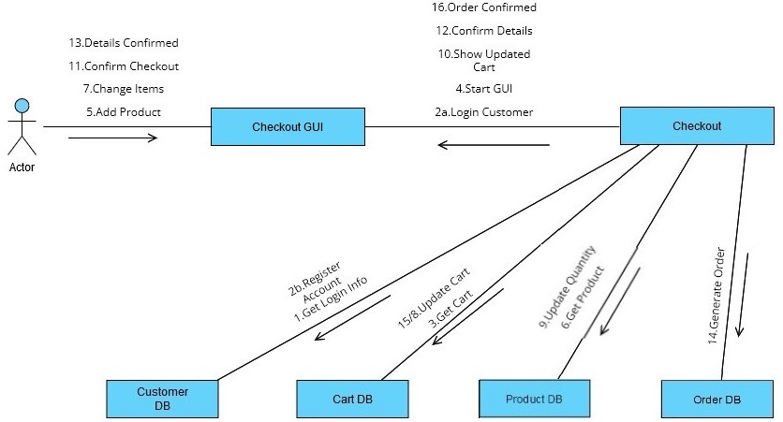

The collaboration diagram explains the relationship between **View Class, Model Class & Controller Class** of our **transaction form.** This diagram specifies all the major events that occur in between the MVC classes, and also creates an ease for the developer to name the methods accordingly.

**STATE DIAGRAM:**

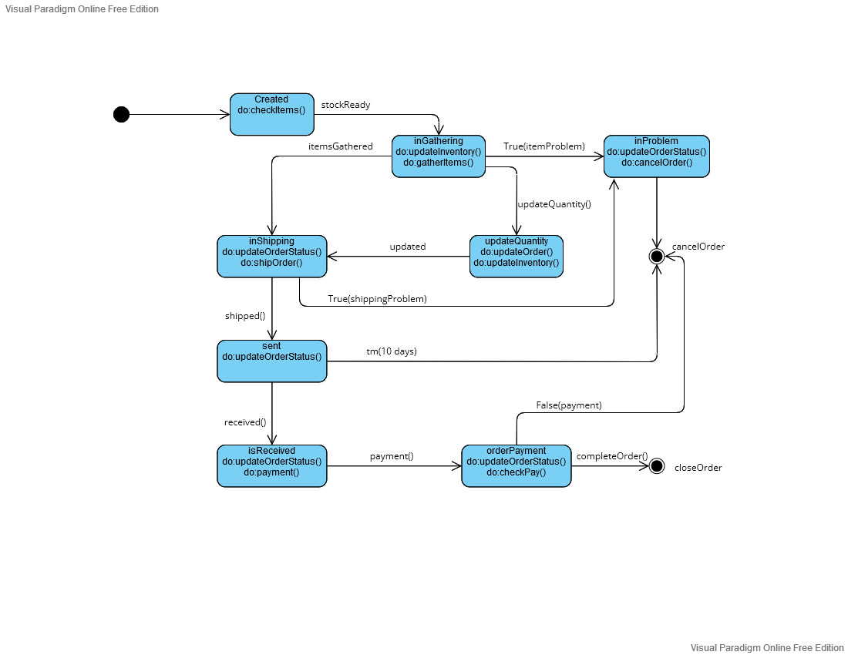

The state diagram explains the different states of our object **(Order)**, how many states an object can retain and achieve before reaching the final state at which the transaction form comes to an end. This diagram allows the developer to make the form according to the given states of order and achieve the most amount of states of an order.